# Gwent concepts

*This is the summary of these* [*articles*](https://www.gwentdb.com/articles/182-gwent-concepts-card-advantage) *on GwentDB and some posts on Reddit.*

## Gwent concepts: round 3: the only round that matters?

Generally, in game of Gwent, one player wins the first round, the other player wins the second round, and the outcome of a match is decided in the third round.

In round 3, you're in it to win it. You're going to play all your cards (with few exceptions), and the things that will determine the victor are:

* Who has **card advantage (CA)**
* Who is **playing first**
* Who has better **card quality**(got from deck thinning)
* **Round length** **(round 2 strategies)**
* The outcome of **random effects (e.g. Create)**
* **Sequencing**
* **Mistakes** - most notably what you choose to play into or around
* Anything **carried over** from previous rounds (most often through resilience)

Actually, there are only three notable concepts to understand in the game **for a new player**:

1. **Card Advantage** is the heart of the game. The battle revolves [вертиться] usually around making your opponent use more cards than you in earlier rounds. You get it through high tempo plays, carryover or silver spies.
2. **Deck Thinning** is a key in deckbuilding. You want to guarantee having access to your key cards and for this you will need to use tutors and units that pop out of your deck to thin as much as possible. Not all decks completely rely on this, but most of the competitive ones do and you will often see decks that play all their cards in a game.
3. The game is in **three** rounds. You usually want to win round 1 and will need high tempo plays in order to do so, but your deck has to have a plan for **round 2** and 3. Sometimes you can just dry pass on **blue coin** in round 1 if you have an engine deck. That deck will be powerful in long rounds which you opponent (winner of the round 1) will give you. Knowing what your opponent's plan is and how it compares to yours is the key to winning games.

In addition, a new player with some experience should learn how mulligan feature works in this card game and how to predict what cards will appear in the round 2 and 3.

# 

# Gwent Concepts: Card Advantage

Card advantage refers to the difference between the number of cards in your opponent's hand and your cards.

Why is it important?

* More cards = more points
* Importance of Last Play (last say)

Perhaps more importantly, the combination of card advantage and who plays first determines who will have the last play of the round (sometimes multiple last plays in a row, if the card advantage is large). The importance of this varies from deck to deck and from match-up to match-up. Some examples of cards that care about this are: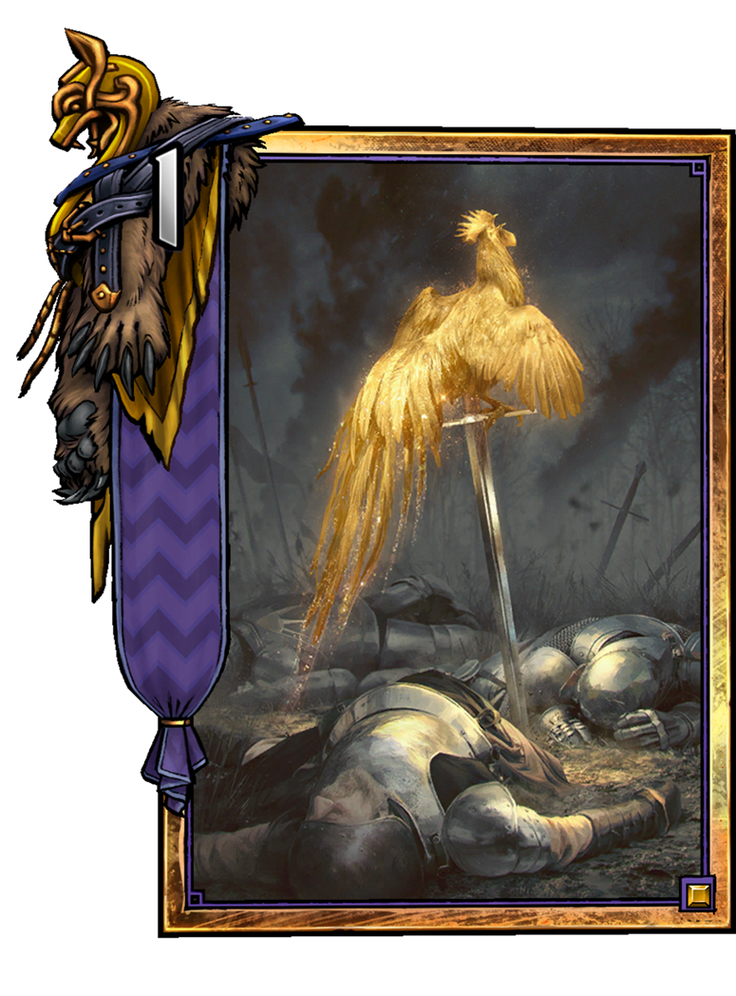

* Succubus - The later you play this, the less likely it is that your opponent has an answer.
* Merigold's Hailstorm - Playing this as the last play can allow you to hit more units.
* Kambi - Nullifies any points either player has accumulated so far. The outcome of the round will depend on how many cards players have remaining (and the quality of those cards)
* John Natalis, Queensguard, Joachim de Wett, etc… - High point plays such as these become better if your opponent doesn't get the chance to respond to them (with something like a Merigold's Hailstorm or Geralt: Igni)
* Vilgefortz into Ciri:Nova - Ciri:Nova is the most powerful card in the game if she is the last card placed on the board but she is so weak when opponent can kill her using Vilgefortz or Scorch. So CA is the most important thing for decks builded around Ciri:Nova.

## **How do you gain Card Advantage**

If you want to gain something in Gwent, there is always a tradeoff (компромисс). To gain card advantage you often need to sacrifice card quality, points, or another valuable resource. 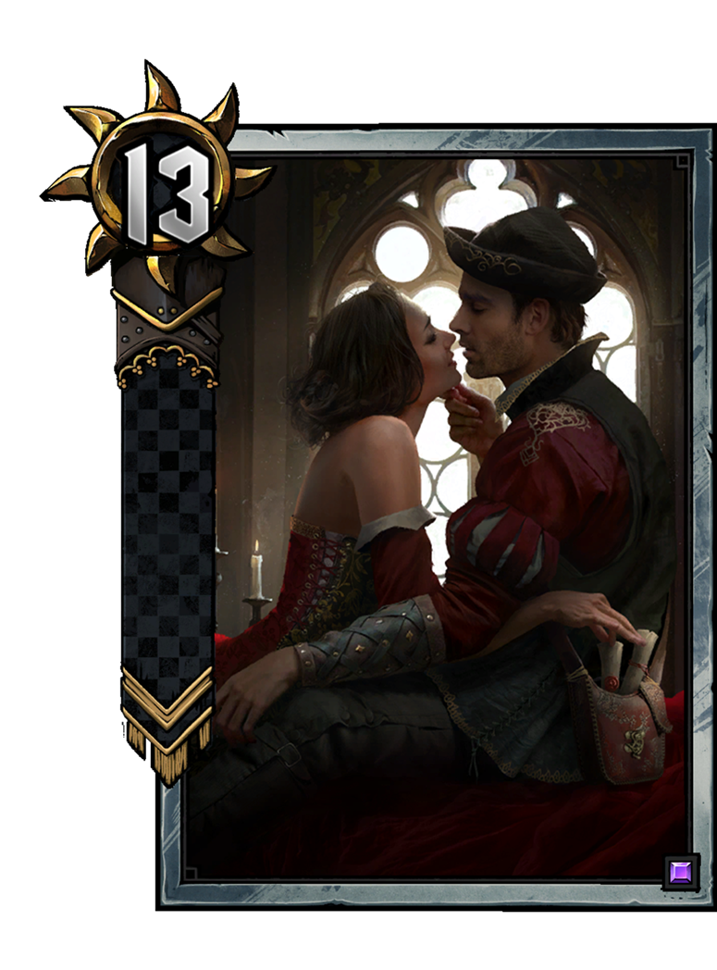 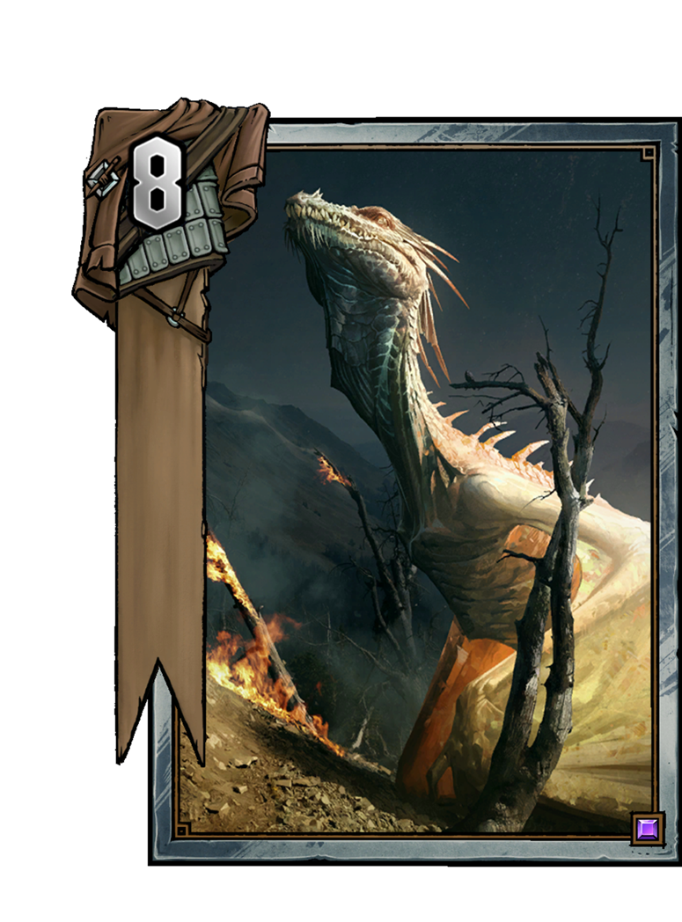 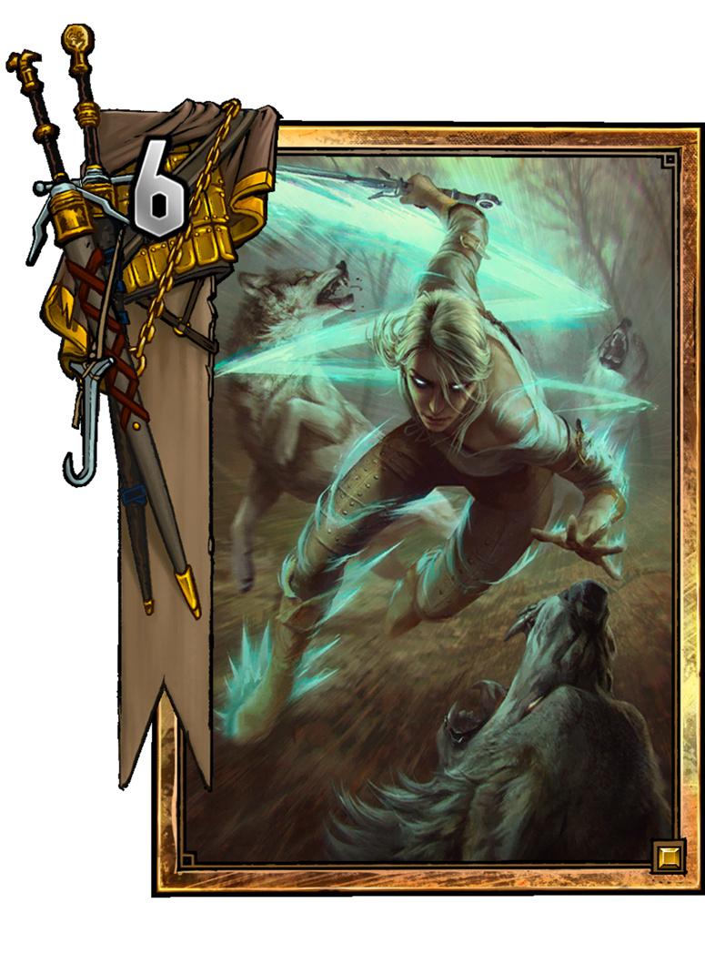

There are three different ways to get CA in Gwent :

1. Card Advantage spies. Play spy to get CA and additional deck thinning. When to play spy:
   * You win round 1 and you want to bleed opponent in round 2 (or you know your opponent has a wardancer or another carryover)
   * Your opponent passed in round 1 and you are ahead of more than 13 points. You can throw away your spy without loss of any points. This is bad because you can bleed your opponent in round 2 and you waste a silver card.
   * You can block Scorch/Igni or you can use your spy to move an enemy on it's row with weather.
   * Don't play spy in round 3!
2. Gold cards like Ciri, Ocvist. Be aware of locks and removal :)
3. Passing when ahead (or at parity). If you pass while you have more points on the board in round 1, your opponent has two options:
   * They can pass, allowing you to win the round - this is usually a very good outcome for you, as that means they had essentially thrown away a card last turn.
   * More often, they choose to play one or more cards in order to overcome your score, which would improve your CA.
4. In round 2, the former[первый вариант] is not an option if you had won the first round, so your opponent is obliged to play more cards. Situations where this might gain you card advantage include:
   * Making higher point plays than your opponent (because they are setting up their engine e.g. weather) and passing quite early in the round. You need a nice **tempo** for that.
   * The **'dry pass'**. Passing in round 2 after winning in round 1, forcing your opponent to play a cards (provided they don't have carryover, or more precisely, more carryover than you).

## **CARD ADVANTAGE ISN'T EVERYTHING?**

Card advantage almost always comes at a cost - whether that be having to use better cards than your opponent before round 3 or not achieving other important objectives, such as thinning or winning the round. It is important to not get carried away and spend too many resources in the pursuit of card advantage, as that might lead you to not having enough firepower to win the match. But in this game, where there are a problem with **Coin Flip**, CA is the most important thing.

# 

# Gwent Concepts: Thinning

In Gwent, it is almost always correct to play decks of the smallest possible size - 25 cards. There are a plethora [большой избыток] of reasons for this, but they all revolve [вращаются] around improving the **consistency** of your deck, allowing for your game plan to be executed more reliably. This is ever more important in Gwent (compared to other CCGs) because of the limits placed on the amount of Gold and Silver cards that can be included in any deck. Having a larger deck size would result in seeing these more powerful cards less frequently, and would decrease the average value of cards you play.

## **Increasing your deck's consistency through thinning**

The concept of thinning encompasses [охватывает] cards that remove other cards from the deck in some way and thus decrease the remaining deck size. Thinning can take all manner of forms, from units that pull out copies of themselves (known as 'mustering'[собирание]) (e.g. Mahakam Volunteers), to units that allow you to play a specific card from your deck (e.g. Pirate Captain), to units with the words 'draw a card' imprinted upon them (e.g. Avallach).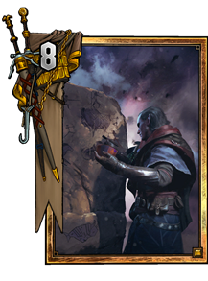

The most important component of thinning is *the removal of bronzes from the deck*. This helps optimise your draws at the start of rounds 2 and 3, maximising the chances to grab your powerful silvers and golds, and making your deck more consistent.

There is a note on thinning and sequencing. It is desirable to increase the average card quality and power of the cards you’re playing by thinning as many bronzes out of your deck as you can before using draw effects like *Avallac'h*, or effects that allow you to play one of the top cards of your deck, like *The Last Wish*.

## **The costs of thinning**

Since thinning is generally seen as a benefit, cards that thin have one or more drawbacks to balance that out. These include:

* restricted [ограниченные] mulligan options. You are often obliged to mulligan these cards away, which constrains your ability to freely optimise your hand and blacklist. **E**: Roach,Blue Mountain Command, Dun Banner Light Cavalry.  
  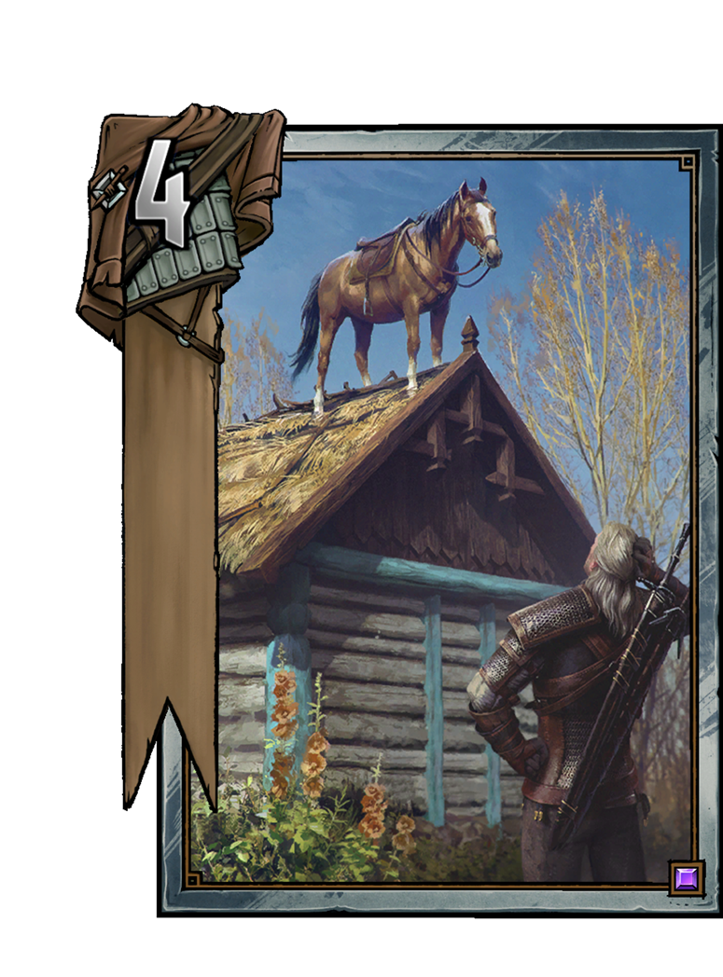 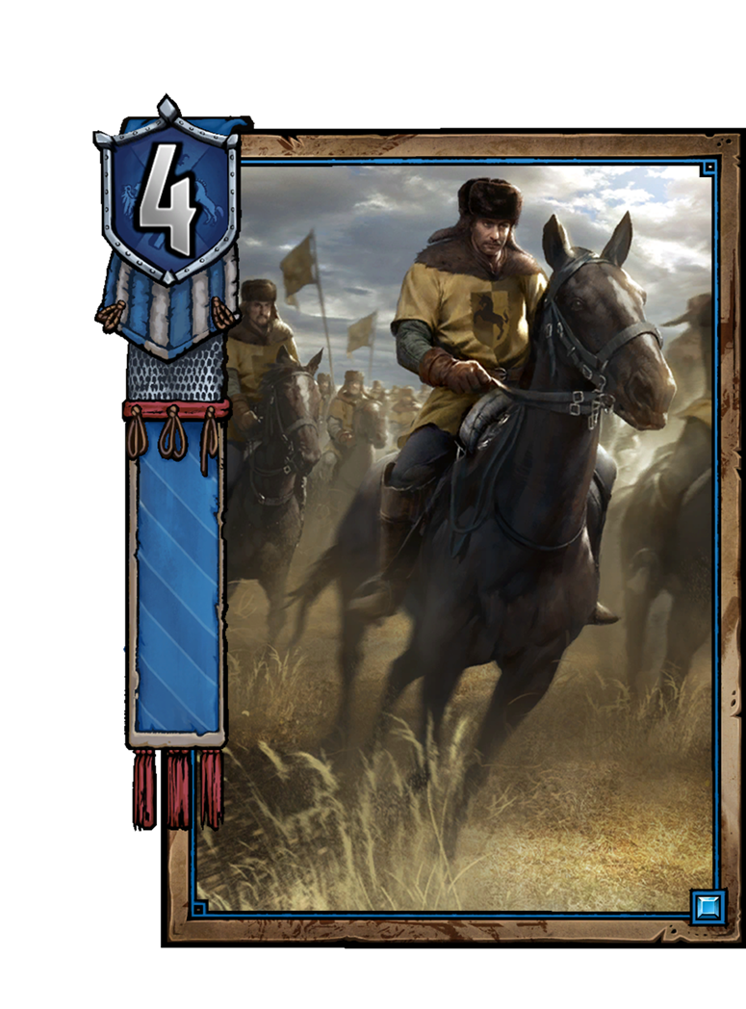
* decreased power or randomness. There are definitely ways to mitigate both of these drawbacks, for instance by playing multiple Impera Brigades with your Emissary cards or making sure that every bronze unit in your deck will provide good value in the event that it gets pulled by Rally. **E**: Emissary, Elven Mercenary, Barclay Els.  
  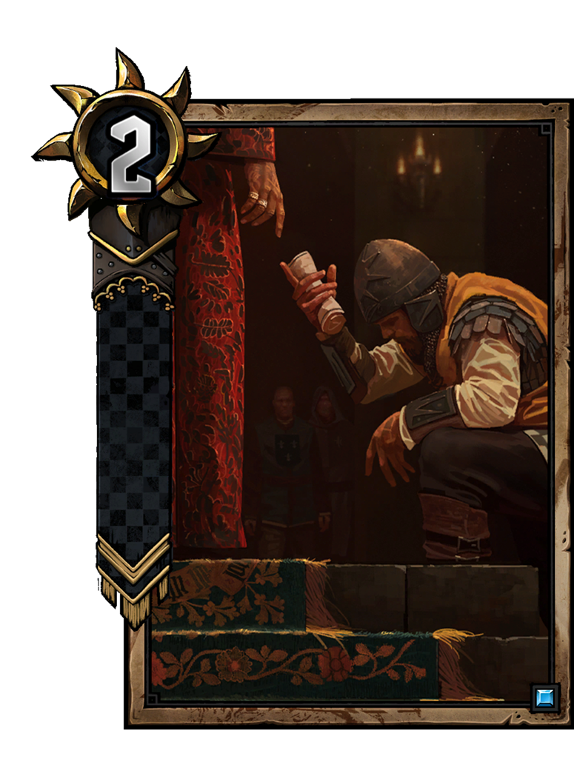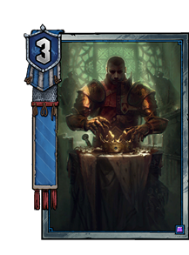
* the opportunity cost of using silver and gold slots for thinning. **E**: Nature's Gift, Royal Decree, Alzur's Double–Cross, Ge'els, The Crones.  
  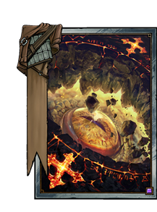 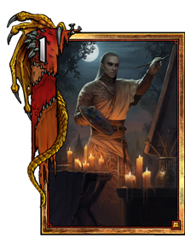
* lack of flexibility. Some thinning cards, such as Reaver Scout are conditional on what cards you have on the board, or in your deck.  
  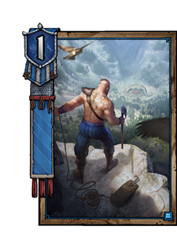 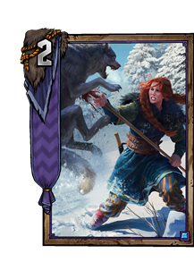

## **The perils (риски) of thinning too much**

While the previous section considered the costs associated with individual thinning cards (or card sets), there are also drawbacks to running too many of these cards in a single deck:

* over-thinning. Everyone starts a game of Gwent with 10 cards, and draws 3 more over its duration. Thus, in a typical 25 card deck (which is what you'll be running under most circumstances), it is imperative that you include 12 or less sources of thinning, otherwise you'll simply run out of cards! (there are some interesting exceptions to this - discussed in the next section)
* diminishing returns [уменьшение прибыли]. There are definitely diminishing returns to thinning, exacerbated by the mulligans at the start of rounds 2 and 3. Thinning 10-12 cards decreases the value of your round 2 and 3 mulligans and thus also reduces the value of situational cards like Dimeritium Bomb and Mardroeme.
* offensive thinning. Another knock against excessive thinning is that there are a number of cards in the game that allow your opponent to thin your deck, which can potentially leave you with no cards to draw. A perfect example is Tibor Eggebracht,

## **Using thinning to your advantage**

Despite all the pitfalls of excessive [чрезмерного] thinning, there are several ways to benefit from it, or at least mitigate the problems outlined above:

* conditional thinning. This refers to cards that can thin your deck, but don't have to, and are still powerful if you don't. There's only a few examples of these, most notably Vicovaro Novice choosing to copy the ability of an Ambassador rather than an Emissary.
* including more than 25 cards. You can do this if you aware of Mill but...**The more cards you run, the fewer silvers and golds will find their way into your opening hand**. Ordinarily there are other drawbacks too, such as decreased consistency and having to pay a cost for including more bronze thinning, so this is almost never correct.
* thinning in reverse. And finally, there's a few cards in Gwent that allow you to increase your deck size by putting cards back into your deck. The most notable examples are Ciri: Dash, Assire var Anahid and Nenneke, and these can be used to enable excessive thinning and/or to provide a payoff for it. For example, you can shuffle back a roach and/or other powerful silvers with Assire to add even more power to your final round gold and increase the card quality for your round 3 draw + mulligan. Certanly, you can even shuffle enemy's bronze units to break his mulligan.

# 

# Gwent Concepts: Going First

## **Who goes first?**

* Round 1: Randomly determined by the infamous coinflip
* Round 2: The winner of round 1
* Round 3: The winner of round 2
* In the case of a round 1 tie, the player who went second in round 1 goes first.

So in order to go second in round 3, you just need to win round 1! While this may sound easy (we’ve all won a few round 1s in our life), winning usually involves committing more resources in round 1 than your opponent, a disadvantage that you may struggle to reverse in round 2. This can ultimately lead to you playing at a card disadvantage and/or with inferior card quality in round 3.

Going first does have a few situational advantages. It can be beneficial to go first if:

* **Your deck requires setup which can help eliminate your opponent's setup.** Example: You might want to go first in a King Bran or Morvran Voorhis mirror match so that you can develop warships and mangonels earlier than your opponent, and threaten to kill their developments using yours.
* **You are fighting over a common resource**. Example: You want to resurrect your Prince Stennis before your opponent can Caretaker it.
* **You need to make a play before your opponent has a chance to act**. Example: Decoying the Combat Engineer'ed Avallac'h before your opponent can Assassination it.

As you can see, these are all quite niche and are usually outweighed by a combination of the following disadvantages:

* **Less reactivity**. Going first decreases the value of your reactive plays. On your first turn there is nothing for you to damage with Alzur's Thunder or Impera Enforcers and no obvious row to apply weather to. By your second turn your opponent has only played one thing to interact with, whilst by their second turn you've played two.
* **Less information**. Going first gives you less information about your opponent's strategy (for instance: should you play your units into weather or risk giving your opponent Drowner value?).
* **No opportunity for last play** (when on equal cards). If both players have the same number of cards in round 3, going second gives you last play, which allows you to make better reactive plays, or play a card that your opponent cannot react to (for more about the importance of last play see last week's article)

## **The flipping coin**

When one of the players passes in round 1, the number of cards in players’ hands at that point is determined by the initial coinflip. Without the meddling of card advantage spies, or Ocvist the following can occur:

**Going First**

* If you are the first to pass, you will have the same amount of cards in hand as your opponent (at that point).
* If you are at any point unable (or unwilling) to overcome your opponent’s points, their pass will force you to play an additional card, allowing you to win the round, but at the cost of being 2 cards down. However, this can be somewhat difficult to accomplish for your opponent, as it means that (for example) their first 5 cards were stronger than your 6 (or 9 stronger than 10).
* It is possible that your opponent will focus their efforts on beating your score, giving you little to no opportunity to pass while ahead, and forcing you to lose the round on even cards if you do.

**Going Second**

* If you are the first to pass, you will have one more card in hand than your opponent (at that point).
* You have the option of passing first and losing the round 1 card down, which the player who went first does not always have. That is, of course, unless your opponent passes earlier than you anticipated.
* If the round continues until the very last card, you have the advantage of last play (or the option to pass instead of playing perhaps your most valuable card).
* Overall, you have a lot more room for error, and a little more control over the length of round 1 than the player going first.

Even if you use a spy to ‘reverse’ the coinflip after going first, you would generally end up worse off than if you went second (under the same conditions).

## **How valuable is it to win round 1?**

If you win round 1, you are guaranteed to go second in round 3, which has a number of benefits, as we have learned. But perhaps more importantly, you get to choose when to pass in round 2 and dictate the length of round 3. This gives rise to a plethora of strategies, including the immediate dry pass (forcing opponent to play one card if they don’t have carryover) and bleeding (ridding your hand of low value plays).

Generally, the difference between winning and losing round 1 is worth around 2 cards, and I would rank the common round one outcomes as follows:

* Win at parity OR Lose 2 cards up (Good)
* Win 1 card down OR Lose 1 card up (Neutral)
* Win 2 cards down OR Lose at parity (Bad)

The outcome in which you win is usually slightly better out of each of those pairs (though that can vary between match-ups and board states). But in order to understand how you want round 1 to end (in a specific match-up, game, situation), we will need to dig deep into what you can do in round 2 after either winning or losing.

## **Gwent concepts: round 2 strategies**

In order to understand how good a particular round 1 outcome is, we must consider what it will allow you to do in round 2. If you’ve won round 1, you’re in the driver’s seat, can decide when to pass, and how long round 3 will be. If you’ve lost, your fate is in your opponent’s hands.

### **Round 1 outcomes**

For now, suppose that carryover does not exist. How would you rank the outcomes of round 1? Would you prefer to lose 1 card up or win one card down? For most situations, the ranking [расстановка] of common outcomes (from best to worst) is as follows:

* Win at equal cards
* Lose at equal cards
* Win 1 card down
* Win 2 cards down :(
* Lose 2 cards up :(
* Lose 1 card up
* Win 1 card up :)
* Win 2 cards up :)

This ranking suggests that the difference between winning and losing round 1 is valued at between 2 and 3 cards, which seems rather drastic[крутое].But this is because winning round 1 gives you the option of:

* **Round 2: Dry pass** - Passing immediately at the start of round 2 (after winning round 1), which forces your opponent to play exactly one card in order to win the round.
* **Round 2: Bleed** - Playing out the round in such a way as to maximise your card quality for round 3 relative to your opponent’s. More simply - playing cards that are worse than your opponent’s in round 2.
* **Round 2: Tempo** - Playing some high point cards and passing while in the lead. In some matchups, particularly when your deck requires a lot less setup than your opponent’s, it can be correct to play a sequence of powerful high point cards before passing, leaving your opponent at a deficit that requires multiple cards to overcome. This can also be a good strategy if your opponent’s plays at the start of round 2 are particularly low tempo, as they attempt to establish carryover (with Barbegazi) or card advantage (with Frightener) instead of focusing their resources on winning the round. By playing high tempo you are essentially trading card quality for (potential) card advantage, which can be a very good deal for decks that have last-play reliant finishers (like Succubus). In the event of your opponent having more carryover into round 2, high tempo plays can sometimes allow you to gain card advantage (which passing immediately won’t), if your opponent can not keep up. Bear in mind that your plays will have to overcome the difference in carryover, as well as the cards your opponent responds with in order for card advantage to be gained.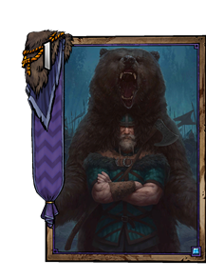
* **Round 2: 2:0** - Knocking out your opponent in the first two rounds, instead of waiting for the third.

### **Reasons for bleeding instead of dry passing include:**

* **Your opponent’s cards scale with round length**. By dry passing, you're allowing for the longest possible round 3. This can be a problem if your opponent has a lot of cards that scale with round length (like Korathi Heatwave, Merigold's Hailstorm, Kaedweni Siege Support). If your opponent has a lot more of those cards than you do, it can be beneficial to shorten the last round's length, even if this comes at the expense of card advantage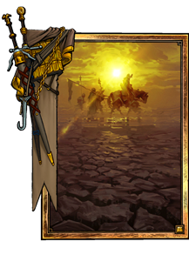
* **You have access to other ways to gain card advantage**. Playing a spy (if your opponent doesn't have a counter spy) in round 2 after a round 1 win allows for the same benefits as dry passing (your opponent using 1 card more than you this round), but also allows you to bleed, if you believe that the worst cards in your hand are worse than your opponent's. This allows you to improve your card quality for the final round. Of course, if you can play the spy at little cost in round 3 (for instance by killing it with Menno Coehoorn), it is probably better to dry pass instead.
* **You need to set up for round 3.** This can include establishing carryover with cards like Barbegazi, increasing the strength of round 3 plays using Hawker Support, or making sure that your Priestess of Freyas have enough targets.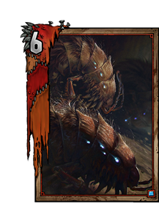
* **Your opponent has more carryover into round 2.** Your opponent having carryover does a very good job of preventing the dry pass - if you pass, your opponent can also pass, and win the round, thus not giving away any card advantage. In fact, your opponent having more carryover alters our entire 'Round 1 Outcomes' ranking, possibly making it more beneficial for you to lose round 1 up a card rather than win it down a card!

### **Strategy TL;DR**

* **After winning round 1, your round 2 objective is**: to maximise your chances to win in round 3. You do this by making sure you have more resources (card advantage, card quality, etc…) than your opponent.
* **Dry Pass** when it provides you with card advantage and if you want a long round 3.
* **Bleed** when you want to shorten round 3 or believe that your worst cards are worse than your opponent’s, or you want a long round 2 with weather :)
* **Tempo** your opponent out if they can’t keep up, and/or if you value card advantage over card quality.
* **Go for a 2:0** only in rare circumstances.
* **Transition between strategies** as needed. The optimal strategy may change depending on what your opponent does! It is always better to revert to a superior strategy than to see a mistake through to its bitter end.

### **Think more**

* Optimize your draws/mulligans
* Understand what your opponent could have in round 3
* Watch their plays. Maybe he has a great combo (Letho + Regis)

## Gwent Concepts: Mulligan and Blacklisting

Each game of Gwent begins with a mulligan phase, which allows both players to replace any given card in their hand with a card from their deck up to three times. This happens again at the start of round 2 and 3, but this time only one card is replaced.

Understanding the exact mechanics *behind how cards are shuffled back in and drawn from the deck* is integral to making correct decisions and taking calculated risks in any given game of Gwent.

### **The mulligan algorithm**

Algorithm:

1. Choose a card in your hand
2. This card is **blacklisted**, meaning a card with the same name cannot be drawn for the remainder of this particular mulligan phase
3. The chosen card is placed in a random position in your deck. As far as we know, any position, including the top or bottom of your deck, is equally likely. The order of the other cards remains the same.
4. Draw the top non-blacklisted card of your deck*
5. Repeat the process until all of your available mulligans are completed or you decide to end the mulligan.

*Suppose there is a Foglet on top of your deck, and you mulligan another Foglet that gets randomly placed second. Then you would draw the third card from the top.

### **Why mulligan?**

The primary purpose of the mulligan is to get rid of cards that you don't want to have in your hand.

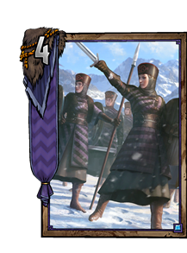 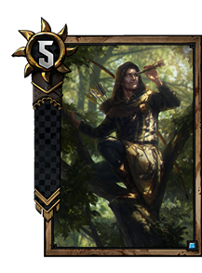 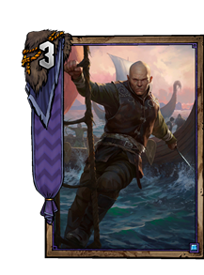

In the initial mulligan, these could be:

* Cards that you want to summon or otherwise obtain from your deck. Examples: Foglet, Queensguard (with King Bran), Impera Brigade (with Emissary)
* Cards that are significantly more valuable in later rounds. Examples: Spotter, Priestess of Freya, Peter Saar Gwynleve (against enemy Spotters)
* Your weakest bronzes, to look for silvers and golds (especially in decks with little thinning)

Contrastingly [контрастно], the mulligans at the start of rounds 2 and 3 should mostly focus on improving your average card quality, and are thus relatively straightforward.

### **In depth: blacklisting**

The blacklisting mechanic ensures that after you mulligan a specific card, you will not draw any cards with the same name during this mulligan phase. Quite importantly, in your initial mulligan (and when using Francesca's ability), the blacklist is shared between all 3 of the mulligans, making sequencing very important - you want to blacklist undesirable cards as early as possible.

Example: Suppose you're playing a monster deck, and the only undesirable cards you are running are 3 Foglets and The Crones. Your opening hand contains 2 of each.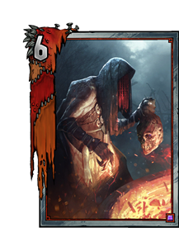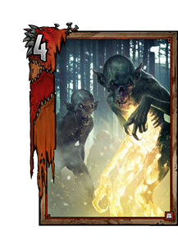 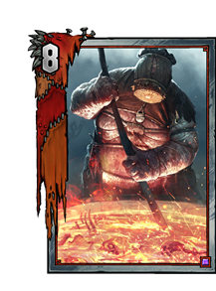 

Your mulligan order should be:

* Foglet, blacklisting 2 cards: itself, and the Foglet that's still in your deck
* a Crone, blacklisting only itself.

The Crones do not have the same names, and thus do not blacklist other Crones. In the scenario where you draw your third Crone in one of the first two mulligans, mulliganing a Crone second gives you the option of whether you want a useless Crone or a dead Foglet in hand

* Foglet, blacklisting only itself (the other Foglets are already blacklisted)

This example is fairly straightforward, as Crones and Foglets are both so undesirable that we would rarely need to consider other mulligan pathways in the scenario outlined[описанном сценарии]. However, bear in mind that sometimes mulligan decisions can depend on the availability of combos, or ways to mitigate the drawbacks of undesirable cards.

### **Food for thought**

* Bear in mind that different players will have different mulligan preferences, and what I've explained above isn't necessarily the only good way to do it.
* Think about the sequencing of your mulligans before starting them. What are the main problems with your hand, and how can they be most effectively solved?
* If you have a good starting hand, you are not obliged to go through with all 3 mulligans. It can often be unwise to perform a third mulligan if your deck still contains undesirable cards that have not been blacklisted, unless it is a risk you're willing to take
* It is not necessary for you to have all of your good cards in your opening hand, as it can occasionally lead to over-killing your opponent in round 1 and running out of steam later in the game. This is especially true if you can thin effectively enough to have a reasonable shot at grabbing your good cards later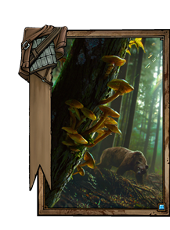
* Mulligan decisions can be heavily **dependent on the matchup**. For instance, some cards (like Mardroeme) may become undesirable, or you may choose to blacklist more aggressively to look for tech cards
* The mulligan is as much an art as it is a science, especially given the limited time given to analyse any given hand. The more you play a specific deck, the more you'll understand about its goals and mulligan strategy

### **Ways to mitigate [смягчать] the impact of undesirable cards**

Some hands are so suboptimal that they can't be saved, even with all the mulligan magic one can muster. However, there are several ways to mitigate [смягчить] the impact of undesirable cards:

* You need to pull out all bad cards from your deck as fast as possible [to get as many other undesirable cards out of your deck], so that you don’t end up drawing them.
* Bleed your opponent out in round 2 (after winning in round 1), by playing these suboptimal cards for little value.

Bleeding refers to a situation where you’re in a position to decide round length, and can play your worst cards out and save the best ones for a later round. This is only a good idea if the cards you play are worse than your opponent’s, and they have no way to capitalise on this bleeding to gain card advantage.

* If you believe that it will often have suboptimal hands, it can be useful to include some safety valves in your deck. A perfect example of this would be running a Toad Prince in a Monster deck to eat an extra Crone or Nekker.

